Contents

The GigMan Project 4

Nomenclature 4

Hosting Requirements 4

GigMan 4

Premium Membership 4

Non-Premium Members 5

iRequest 5

GigMan Page Details 6

Common Elements 6

Home Page 6

Song List 6

Resynchronize Data 7

Add Song 7

Rand. Song 7

Un-played 7

Artists 7

Rand. Artist 7

Genres 7

Categories 7

Set Lists 7

Settings 7

FAQ 7

Credits 7

Profiles 7

Calendar 7

Log Out 7

Profiles 7

User Profile 8

Artist Profile 8

New Artist 9

Settings 10

Master Song List 10

Edit 10

Plays 10

Title 11

Composer 11

Genre 11

Category 11

Collapse 11

Filter 11

Tile/List 11

Lyrics View 11

Chords 11

Lyric Blocks 12

Lyrics Tool Panel 12

Other Tools 13

Song Editor 13

Genre 13

Key 13

Familiarity 13

Title 13

Artist 13

Category 13

Sample URL 13

Lyrics/Chords 13

Song Notes 14

Setlists 14

Setlist Editor 14

Calendar 14

Event Editor 14

Screen Shots 16

Figure 1 iRequest – Calendar View 16

Figure 2 iRequest – Messaging View 17

Figure 3 iRequest – Request View 18

Figure 4 iRequest – Tutorial Screen 19

Figure 5 iRequest – About Screen 20

Figure 6 GigMan – Home Page 21

Figure 7 Home Page – Site Settings Editor Open 22

Figure 8 GigMan – Master Song List 23

Figure 9 GigMan – Master Song List (tiled) 24

Figure 10 GigMan – Lyric View (subscription) 25

Figure 11 GigMan – Lyric View with Song Editor Open 26

Figure 12 Lyric View – Hovered Chord Chart 27

Figure 13 Lyric View – Chords Transposed (from A minor to F minor) 27

Figure 14 Lyric View – Navigation Panel Open and iRequest Data Showing 28

Figure 15 Lyric View – Lyric Toolbox Open 28

Figure 16 Lyric View – Contextual Help Panel Open 29

Figure 17 GigMan – Master Artist List 30

Figure 18 GigMan – Calendar View, Event Editor Open 31

Figure 19 Setlist Display Page 32

Figure 20 Setlist Editor 32

Figure 21 Profiles Page 33

Figure 22 Profile Page with User Profile Editor Open 33

Figure 23 Profile Page with Users Artist Affiliation Editor Open 34

# The GigMan Project

The ***GigMan*** project is a set of tools for musical acts wishing to leverage the power of social media to help drive successful stage shows by including the audience in the act.

The application consists of two web sites; one for the Artist (***GigMan***), and one for the audience members (***iRequest***).

## Nomenclature

‘*Artist’* refers to a GigMan account holder.

‘*Composer’* refers to the composer field value saved with song data. If the Artist is a cover band, or a band whose repertoire consists of originals and covers, the composer name helps define categories for browsing their saved songs.

*Active Artist* refers to the GigMan User’s currently selected Artist affiliation.

*Artist Affiliation* refers to the GigMan Artist accounts that a given GigMan User has memberships with.

## Hosting Requirements

The project consists of two web sites (which can be hosted as subdomains), one web service for brokering data transfers, and a Microsoft SQL Server database.

## GigMan

The ***GigMan*** website serves the artist in two ways; it can be used to manage song content by aggregating song titles, lyrics and chords for the artist and displaying them on the artist’s wireless device. Songs can be displayed in lists and grouped, sorted or displayed by artist, genre or a freeform category field. Additionally, calendar events can be specified by the Artist and displayed to fans via the Artist’s ***iRequest*** account.

The second Artist function is the retrieval and display, on their wireless devices, of input from interactions between the audience, and the Artist’s ***iRequest*** account.

### Premium Membership

Premium membership allows the Artist to save their data in the ***GigMan*** database and share it with affiliates. Premium members can also create and administer calendar events to share with affiliate members and, if the Artist has an ***iRequest*** account, with audience members.

Premium and non-premium Artists using the song management functionality store their data in the browsers Local Storage area, which is generally 5mb per internet domain. Premium Artists can choose to upload their data to the ***GigMan*** database (synchronizing their data) to permanently store their data.

If a member has a Premium Artist and a non-premium Artist account, and uses the same browser for both, the Premium Artist data will overwrite the non-premium data.

Premium members can also create an unlimited number of set lists, which are saved to the database. Non--premium members can create two set lists, which are stored in the browsers local data space.

### Non-Premium Members

Non-Premium members cannot save their data to the GigMan database. Their data is still saved to the ‘Local Storage’ area that modern browsers reserve for each domain, but changing browsers will mean that their data will have to be recreated.

Non-Premium members can only create one set list at a time.

## iRequest

The ***iRequest*** website leverages the cool factor of social media by allowing audience members to send messages and make requests to the Artist in near real time, and browse the Artist’s public calendar, if the Artist is a premium member.

During their show, the Artist can invite the audience to *iRequest.net/BandName.  
BandName* in this case is an identifier the Artist creates in their Artist profile. The identifier must be unique in the GigMan database.

The Artist makes a list of songs available to the ***iRequest*** user. The ***iRequest*** user then makes requests to the Artist (up to five per 24 hour period; the actual number is selected by the Artist). The requests are pushed to the database, and then accessed, tallied and displayed, in the Navigation Panel, by the ***GigMan*** software.

***iRequest*** users can also be used to send messages to the Artist, targeting the leader, the group, or individual members of the act. The Artist can specify who can be targeted in their ***GigMan*** Artist account settings, and individual ***GigMan*** Users can specify whether they receive messages for a given Artist affiliation.

Finally, if the artist is a GigMan Premium Artist, they can make their event calendar available to fans on the ***iRequest*** site.

# GigMan Page Details

## Common Elements

All pages include buttons to navigate to the home page, open the main side navigation panel, go back one page, open the contextual help panel and log out. There is also a switch in the page header which allows the Artist to switch between the classic Metro style and a high contrast style.

## Home Page

The ***GigMan*** Home Page is where the artist lands after logging into their ***GigMan*** account. It provides a stepping off point to other views of the ***GigMan*** website.

There are three control groups on the main page. The first is a drop-down list of all Artists that the logged in user is affiliated with. Selecting an Artist from the list *makes that Artist the Active Artist.*

The second is a search box and submission button. Typing text into the box and clicking the button will take the user to a page that lists all saved songs or artists with the search term in the title, artist name or lyrics.

The third control group is a block of clickable tiles. Clicking a tile will navigate the user to the location of interest.

The tiles on the home page are defined as follows:

Song List: Displays the Artist’s master song list.

Resynchronize Data: If the currently active Artist account is a subscription account, volatile data that has changed can be sent to the database.

Add Song: Opens the song editor.

Rand. Song: Selects one of the Artist’s songs at random.

Un-played: Displays a list of songs that are marked as never having been played.

Artists: Displays a list of all unique song artists from the Artists song list.

Rand. Artist: Displays a list of all songs by a randomly selected artist.

Genres: Displays a list of unique genres encompassed by the Artists song list.

Categories: Displays a list of unique categories encompassed by the Artists song list.

Set Lists: Allows selection and display of any set lists created by the Artist.

Settings: Opens the Site Settings panel.

FAQ: A list of frequently asked questions.

Credits: Displays a list of shout-outs to frameworks and technologies used in the construction of ***GigMan.***

Profiles: Allows access to the Artists User account settings, and band (Artist) affiliations.

Calendar: Opens the Calendar page, where the Artist can create calendar events.

Log Out: End the session.

## Profiles

The profiles page gives the Artist access to view and edit their personal account information and their artist affiliations.

### User Profile

The Artist/User can administer their personal information from this panel. The User can also request membership to any Artist on the site, if the artist has elected to be listed publicly on the site.

The User Profile panel also displays a list of Artist accounts the User is affiliated with.

If any of the User’s affiliated Artists have an ***iRequest*** account which allows audience messaging, Users can elect to turn messaging for themselves on or off at the User-Artist level.

### Artist Profile

The User-Owner of an Artist account can administer their Artist account information from this panel. An Artist member (who is not the owner) can view the Artist account information.

#### Artist Profile for

A dropdown list of all the artist affiliations the current User has. Selecting an artist from the list repopulates the panel with the account information for that artist.

#### List Publicly

A switch to specify whether or not the current Artist account is visible to other users of the site. If the Artist is not public, it cannot receive join requests.

#### Artist Name

The name of the currently selected Artist.

#### Artist Website

The website URL of the currently selected Artist.

#### iRequest URL Name

The identifier used to send audience members to the Artist’s page. The value must be unique within the iRequest database. Once the user is on the iRequest page, the actual Artist name is displayed.

#### Members

A list of the GigMan members affiliated with the Artist. Only active GigMan users can be associated with an Artist.

#### Payments

GigMan Premium and iRequest subscriptions can be paid for by checking the payments of interest and clicking the check-out button. Only the owner of the Artist account can see and use the payment controls.

#### iRequest Settings

If the currently selected Artist has an ***iRequest*** account, the account settings can be administered here.

##### Show Members

Show the members on the Artist’s ***iRequest*** page, allowing messages to be sent by fans.

##### Show Categories

Show or hide the Category column in the ***iRequest*** song list.

##### Show Artist

Toggle the public availability of the Artist’s ***iRequest*** account.

##### Enable Down-votes

Show or Hide the Down-vote column in the ***iRequest*** song list.

##### Max Messages, Max Requests

Controls how many messages or requests an individual fan-user of iRequest can send in a 24 hour period. The maximum is 5 of each per session.

#### Pending Join Requests

If the currently selected Artist has elected to be publicly listed, other ***GigMan*** users can request membership to the Artist account.

### New Artist

The User can create a new Artist account from this panel. The user then becomes the Owner of the Artist account. Data collected for a new Artist are Artist Name, Artist Website, List Publicly and the ***iRequest*** settings.

A User can create as many unique Artist accounts as they want.

### Settings

The User can adjust some aspects of the styling of the website, as it will appear in their browser.

#### Text

##### Font

All of the web-safe font families are selectable as the base font for the site.

##### Size

The base size of the font for the site

##### Color

Text color can be selected using a color picker.

##### Bold/Italic

The base font weight and style can be specified.

#### Lists

##### Ignore Articles

For song list artists or titles that start with the words ‘The’, ‘An’ or ‘A’, list sorting can be specified as either ignoring or including the first word.

##### Song List Page Length

Controls how many entries are shown at a time for tabular lists.

##### Set List Page Length

Controls how many entries are shown at a time for tabular set lists.

## Master Song List

The master song list serves as a stepping off point for the Artist who wishes to use the various lists and views related to song management. It is a list of all songs saved by the Artist, and is a table consisting of six columns:

Edit: Contains three links to allow editing, deleting or incrementing the play count of the song represented by the current table row.

Plays: Displays the number of times the song has been marked as played. Hovering over the number displays the last date the song play count was updated.

Title: The title of the song. Clicking the title takes the Artist to the Lyrics view for that song.

Composer: The original composer or recording artist for the song, if it is a cover. Clicking the composer takes the user to a list of all songs by that composer in the Artists song data.

Genre: The musical genre for the current song. Clicking the genre takes the Artist to a list of all songs in their song data marked as belonging to the genre.

Category: A user defined string allowing further categorization of songs. Clicking the category takes the Artist to a list of all songs in their data marked with that category.

**Tools**:

Collapse: Where display real estate may be an issue, the Artist can choose to hide all but the Title and Artist columns.

Filter: A text box which will allow the song list to be filtered based on the text supplied.

Tile/List: Switches the view between a table style list and tiles.

## Lyrics View

If the Artist has specified lyrics for a given song, they are displayed here, along with chords and song notes, if they were supplied.

Chords  
Chords can be transposed within the lyrics view by using a virtual keypad in the tools panel, or by using the transpose slider on the left side of the page. The slider can be shown/hidden from the tools panel.

Chords can be specified as inline or over line.

Hovering over a chord shows a tablature chart, while clicking inside the tab shows different inversions of the chord.

Chords can be hidden or shown via a switch in the tools panel.

### Lyric Blocks

Lyrics are displayed in blocks, which can be specified as Verse, Chorus or Bridge. Colors can be assigned to the different types via the tools panel.

Clicking the body of a lyric block collapses the block to one line (or two lines, if there is a separate chord line). Clicking the line restores the block.

Notes can be added to songs, and viewed or edited on the fly.

### Lyrics Tool Panel

The lyrics tool panel is accessed through the navigation panel. The available tools are:

#### Transpose

A virtual key pad allows the Artist to transpose the chords associated with the current song.

#### Text

The font size and font for the lyrics view can be specified, independently of the site settings. Only two fonts are available, as Monotype fonts have to be used to keep the chords aligning with the lyrics.

#### Display

Chord visibility and convenience slider visibility are controlled from here.

#### Colors

All of the colors used in the lyrics view are controllable from here via a color picker. This allows separate colors for verse, alternating verse, chorus, bridge, chords, lyric dividers and background.

#### Notes

Display and edit the notes for the current song.

#### Increment Play Count

The GigMan software can keep track of how many times a song has been played. Clicking the Increment Play Count button adds one more to the running total of plays for that song.

#### Play Sample

If an audio sample location was supplied, open a new browser window on the location.

### Other Tools

Buttons for Notes, Page Up, Page Down, Song Info and Edit are available in the page header. Convenience sliders for transposing and font size can be shown on the left side of the page.

## Song Editor

Song data can be added or edited from this panel.

### Genre

The musical genre of the song; there are 32 genres available. Genres are used to categorize songs.

### Key

If chords are being saved for the song, selecting the correct key (just the root) will allow easy transposing in the Lyrics View page.

### Familiarity

There are four levels of familiarity for further song categorization.

### Title

The title of the song. This is a required field.

### Artist

The original recording artist for the song. Multiple artists can be specified by separating the names with a slash (‘/’) character. This is a required field.

### Category

Free form text giving the User a way to further categorize songs. Multiple categories artists can be specified by separating them with a slash (‘/’) character.

### Sample URL

The web location of a recording to use as a reference for the song.

### Lyrics/Chords

Lyrics and chords for the song can be entered here. Chords can be above-line or embedded. If above line, they are entered on a line starting with a tilde (‘~’) character; syllabic placement is by using space characters. If embedded, the chords are surrounded by square brackets (‘[‘,’]’).

Only two (monospace) fonts are available in the Lyrics view to retain syllabic spacing.

### Song Notes

Free form text, up to 8000 characters, can be entered here. This space can be used for such things as production or timing cues for the audio/light techs, synth patches or pedal board patches.

## Setlists

Set lists can be created and accessed from the *Setlist* page.

A set list consists of a *Setlist*, identified by a name, with one or more *Subsets* containing the song data.

The main page displays the set lists in tabular list form, with buttons to navigate any previously created sets.

Premium Artists can save their setlists to the ***GigMan*** database, and share them with affiliates.

### Setlist Editor

The setlist editor consists of a master song list, and a listing of currently defined setlists, formatted into a tree type structure. Sets and Subsets are created in the tree, and Songs are dragged from the song list into the subset.

## Calendar

Premium members can create calendar events to share with affiliates or iRequest users.

Clicking an empty spot on the calendar opens the event editor. Clicking an existing event opens the editor with the event pre-loaded.

### Event Editor

#### Date

Implements a date picker.

#### Venue

The location and title of the event.

#### URL

A web address to associate with the event.

#### Times

The Start time, End time and Setup time of the event. Setup time is not displayed to iRequest users.

#### # Sets

The number of sets being played.

#### Visibility

Who can see the event.

#### Event Description

The details of the event.

#### Artist Notes

Any further notes for the event. This field is not displayed to iRequest users.

# Screen Shots

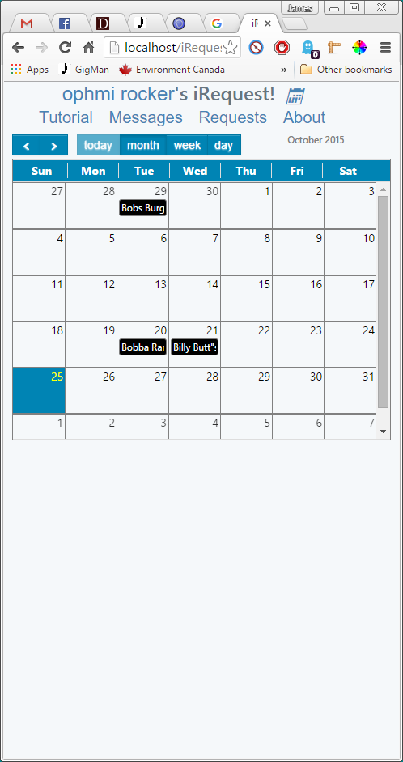

Figure iRequest – Calendar View

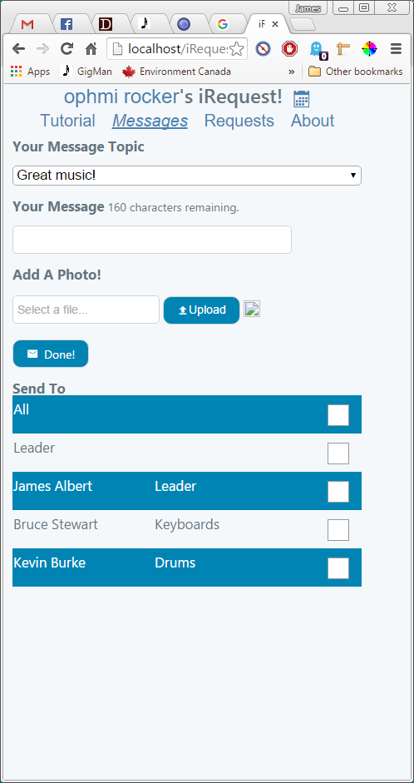

Figure iRequest – Messaging View

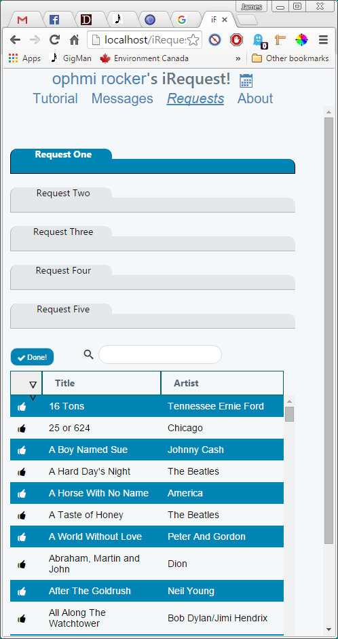

Figure iRequest – Request View

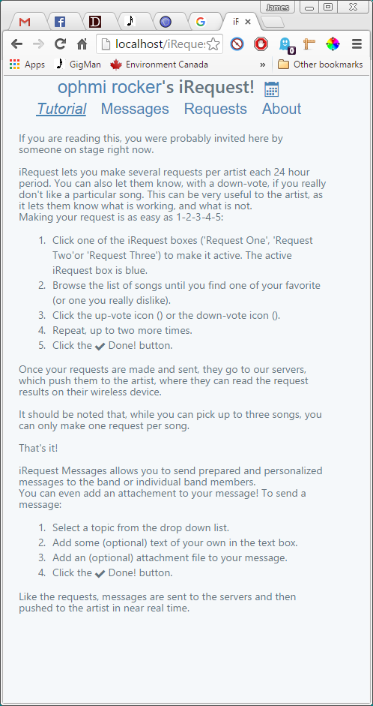

Figure iRequest – Tutorial Screen

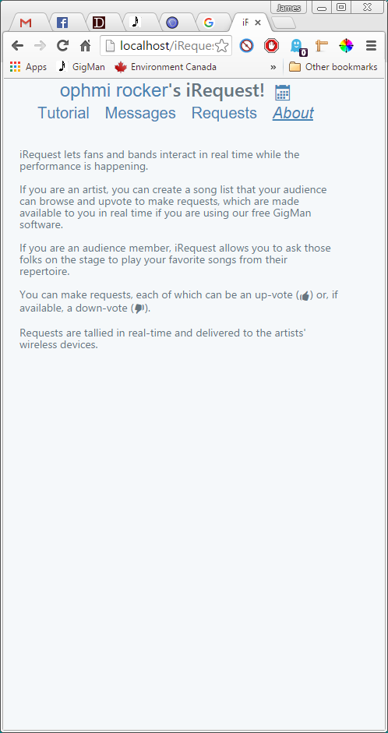

Figure iRequest – About Screen

Figure 6 GigMan – Home Page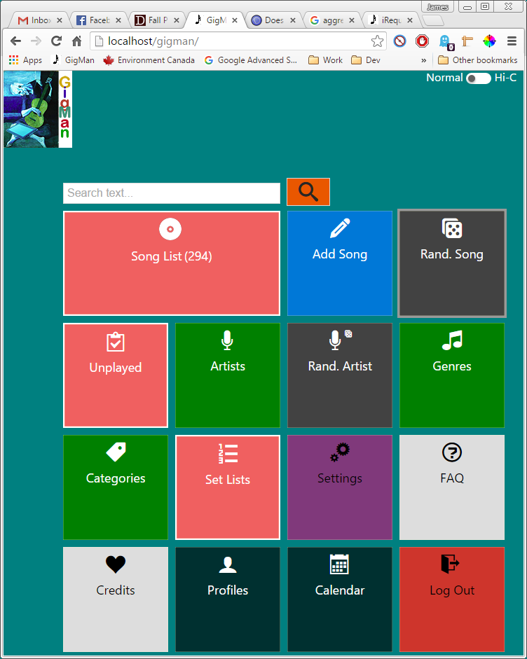

Figure GigMan – Home Page

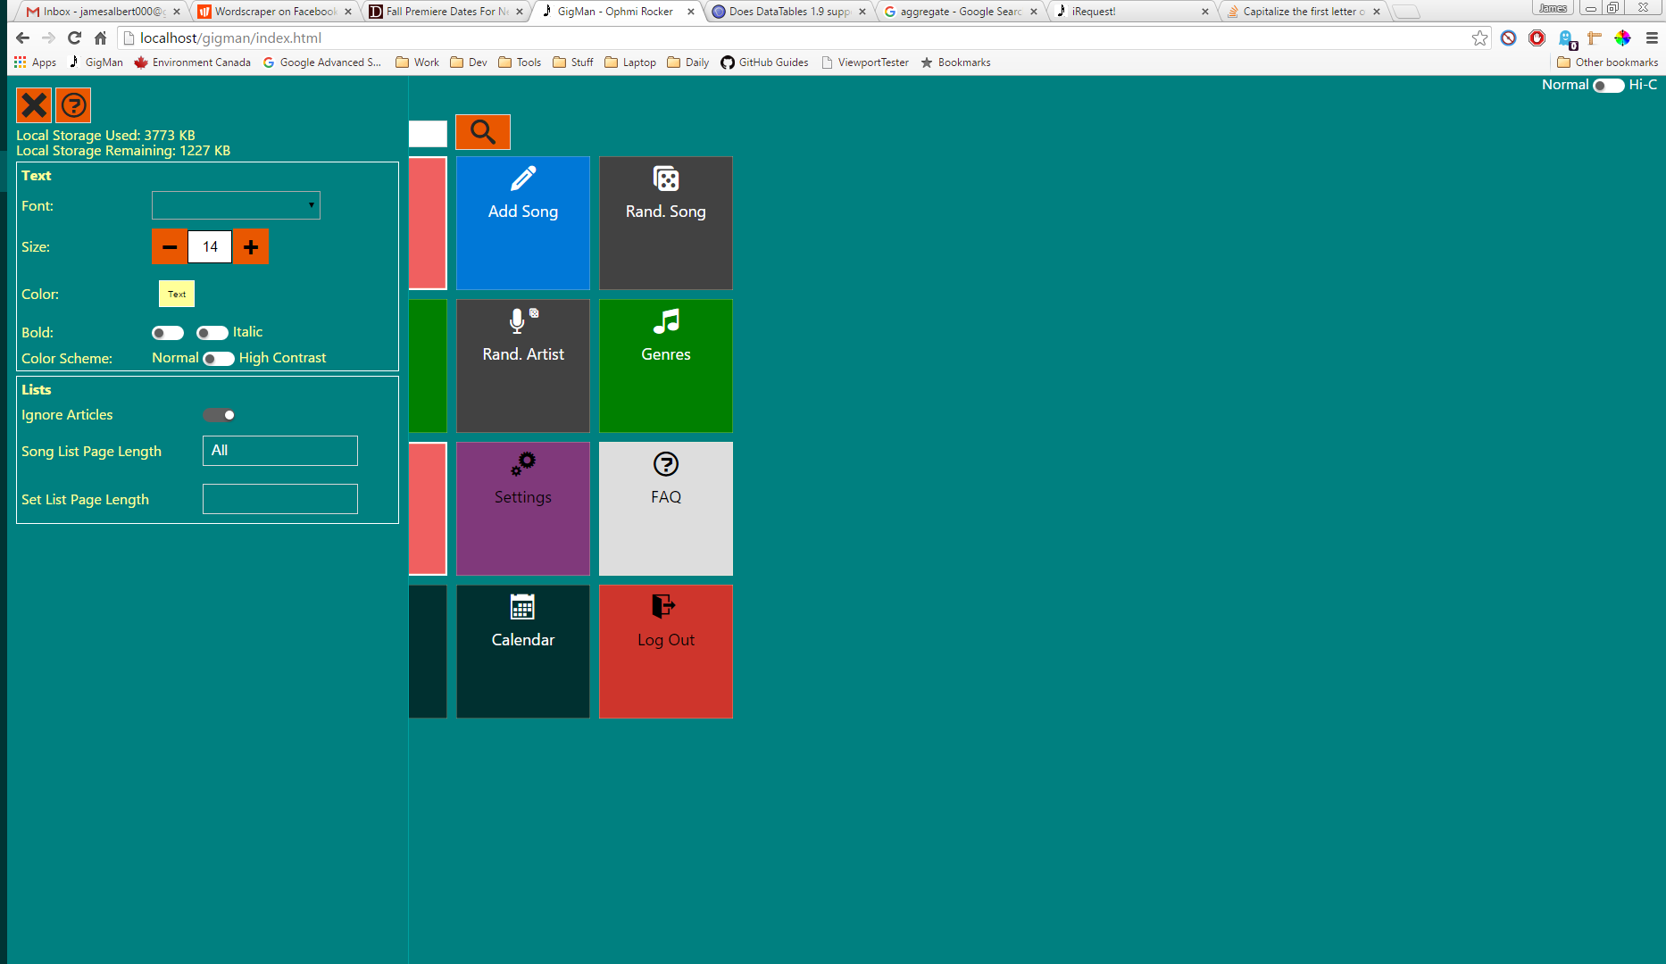

Figure 7 Home Page – Site Settings Editor Open

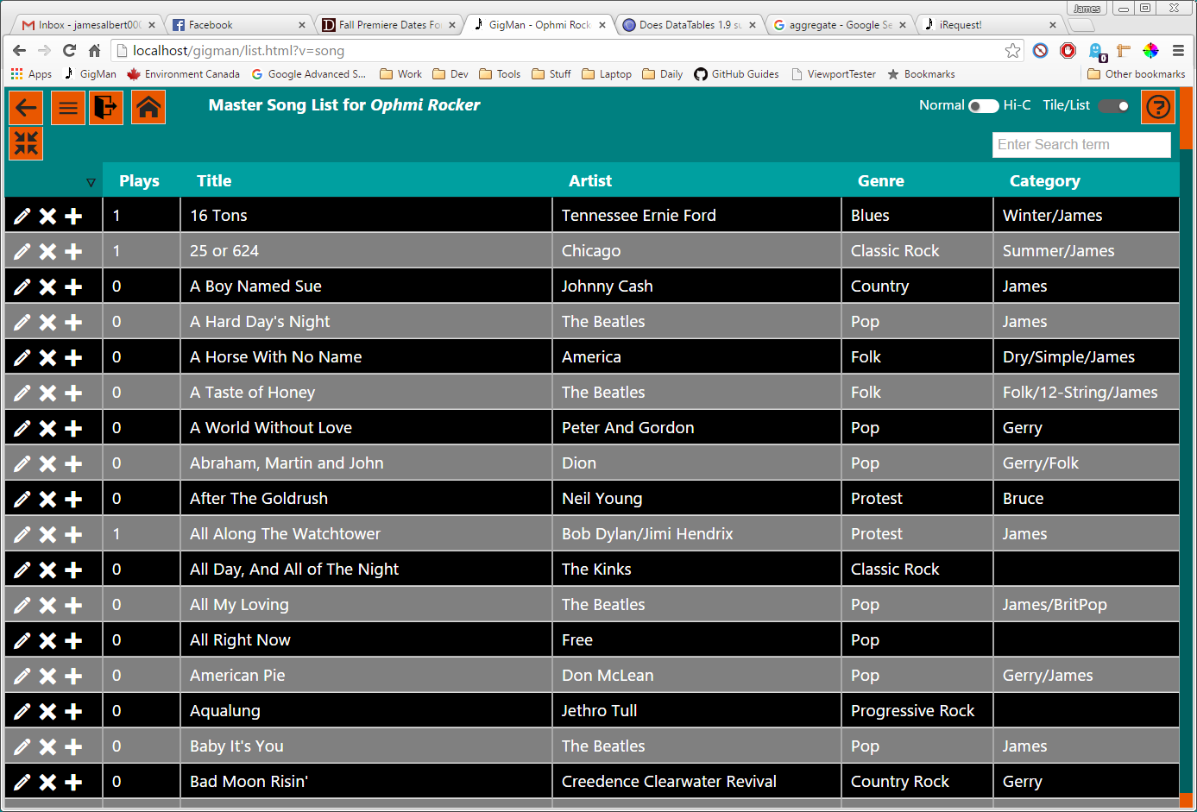

Figure GigMan – Master Song List

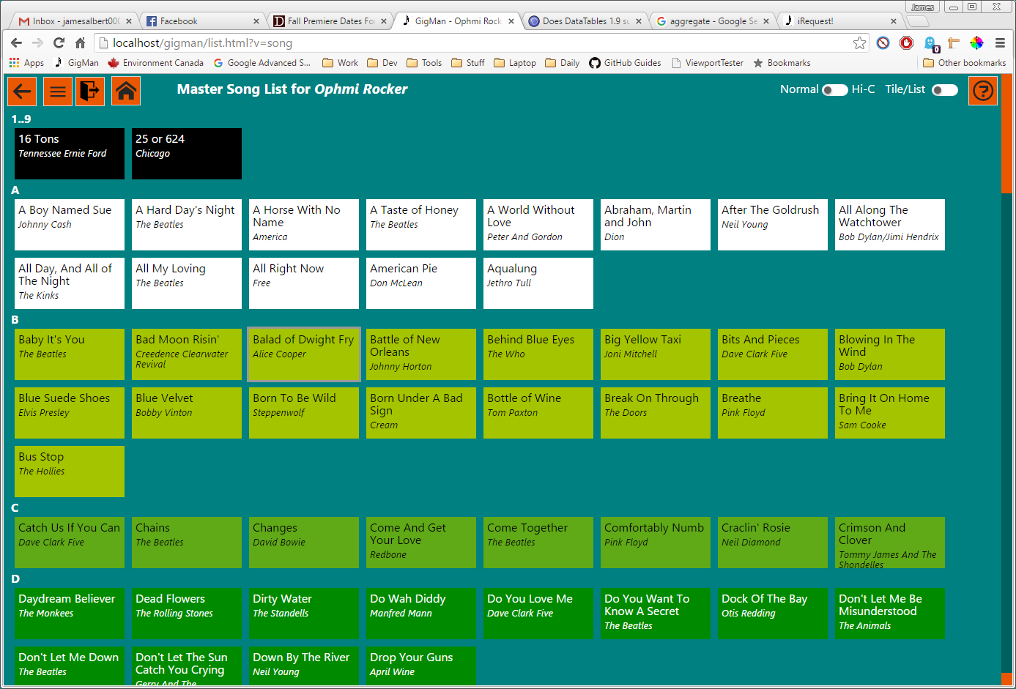

Figure GigMan – Master Song List (tiled)

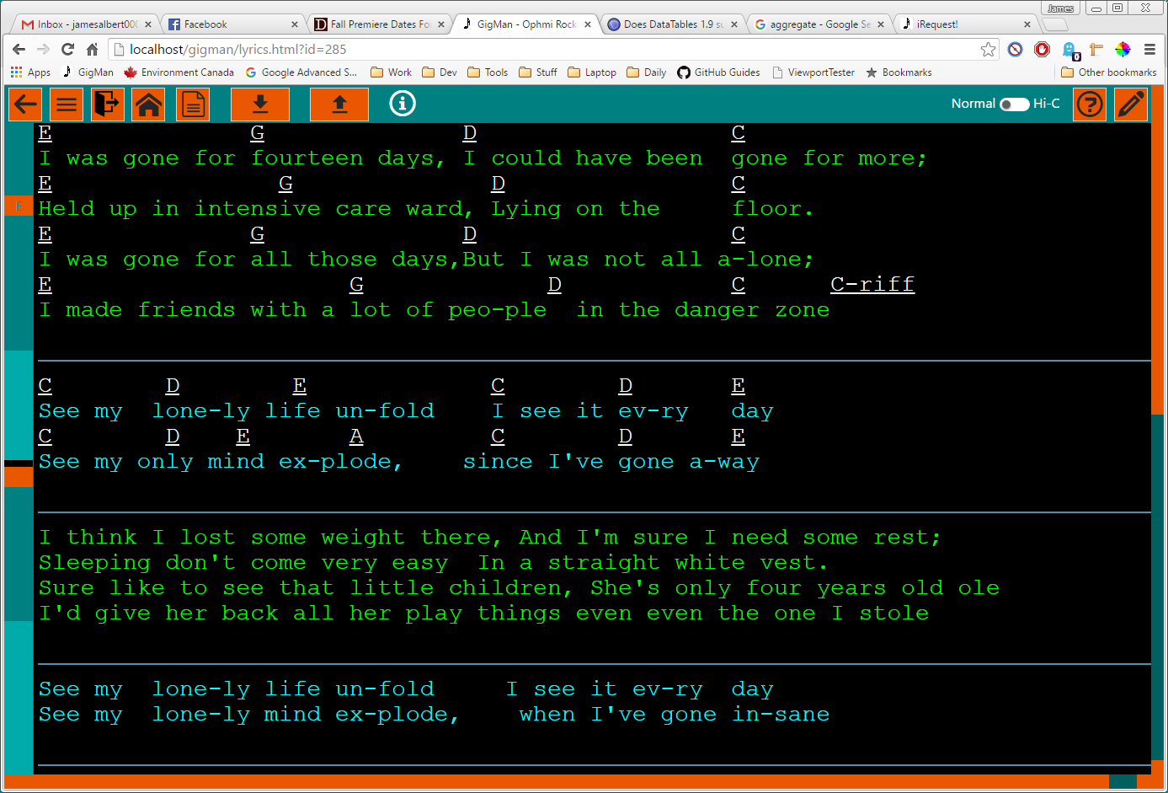

Figure GigMan – Lyric View (subscription)

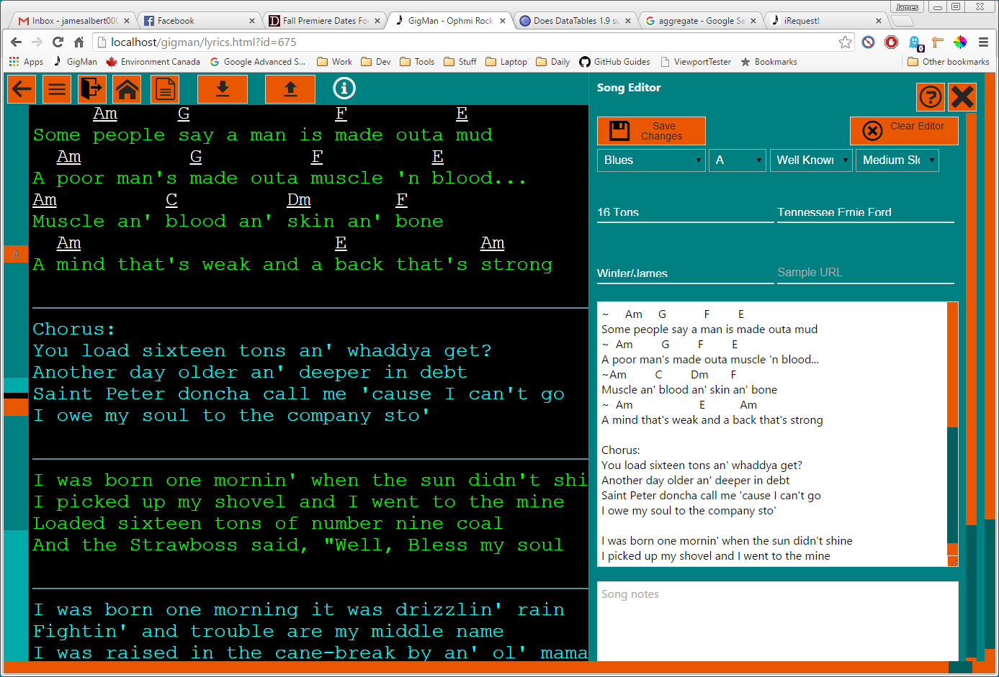

Figure GigMan – Lyric View with Song Editor Open

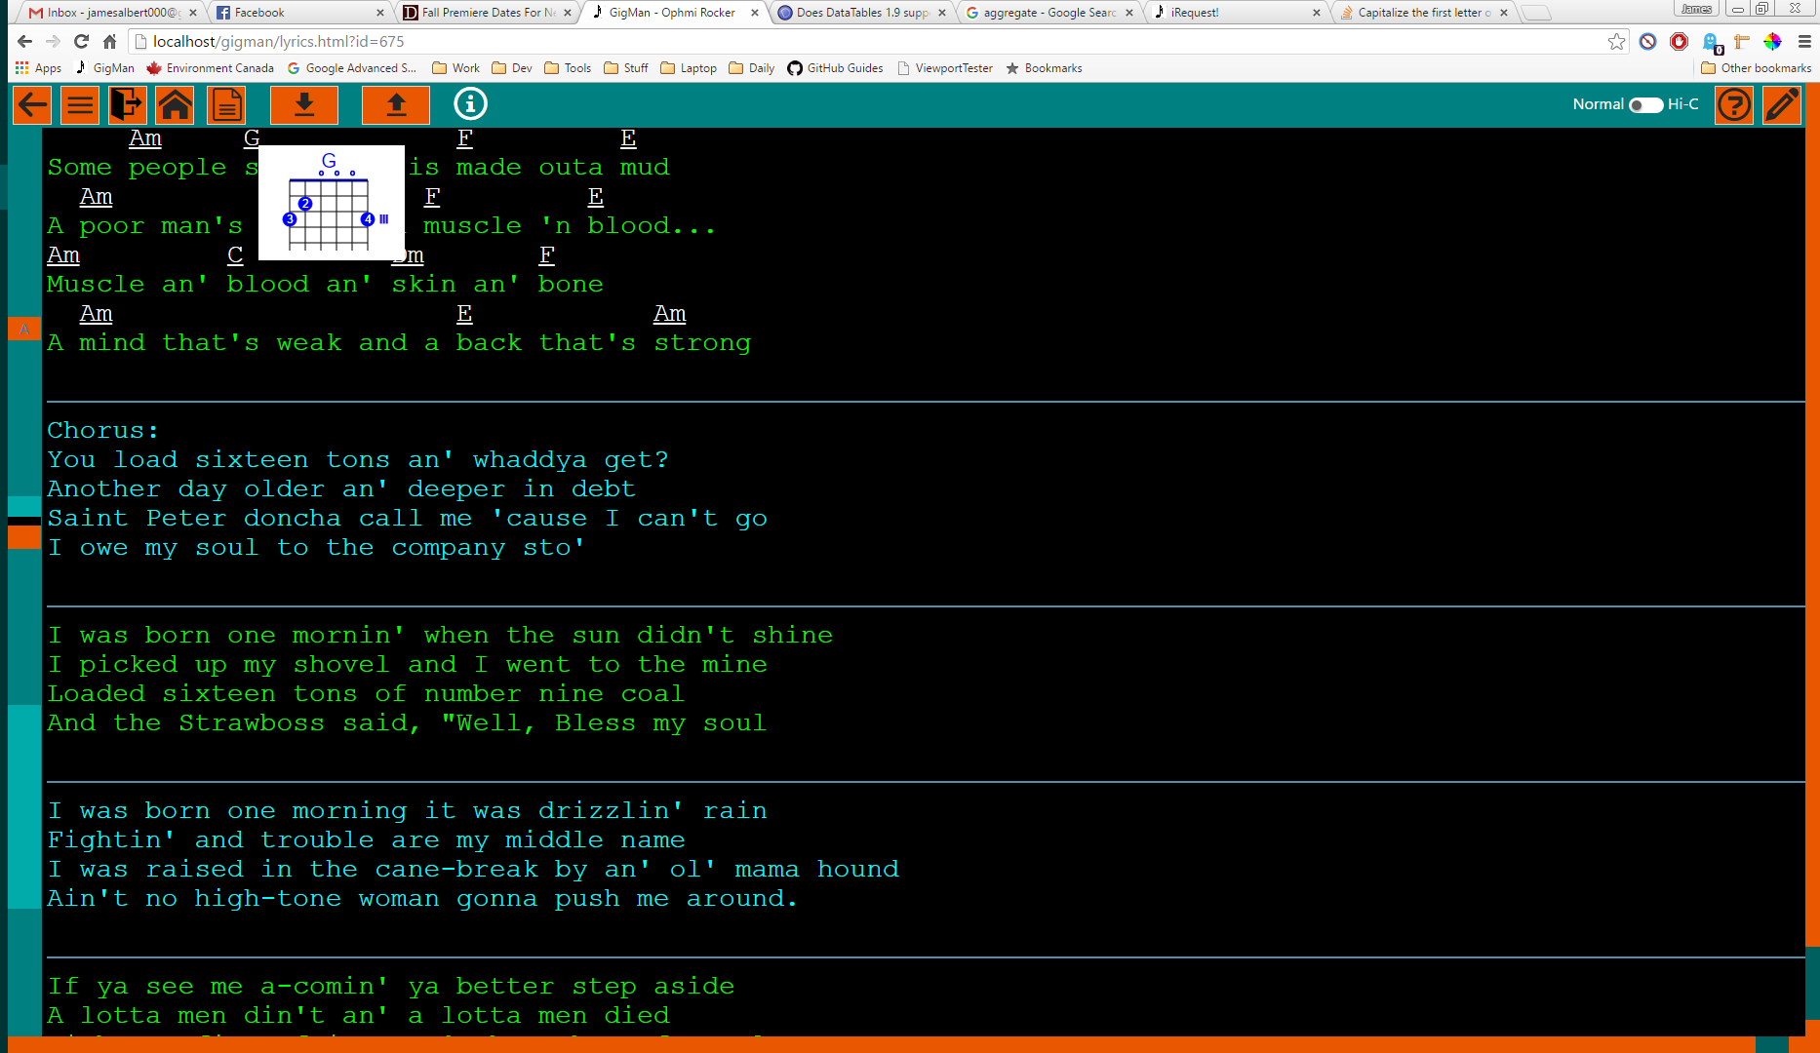

Figure 12 Lyric View – Hovered Chord Chart

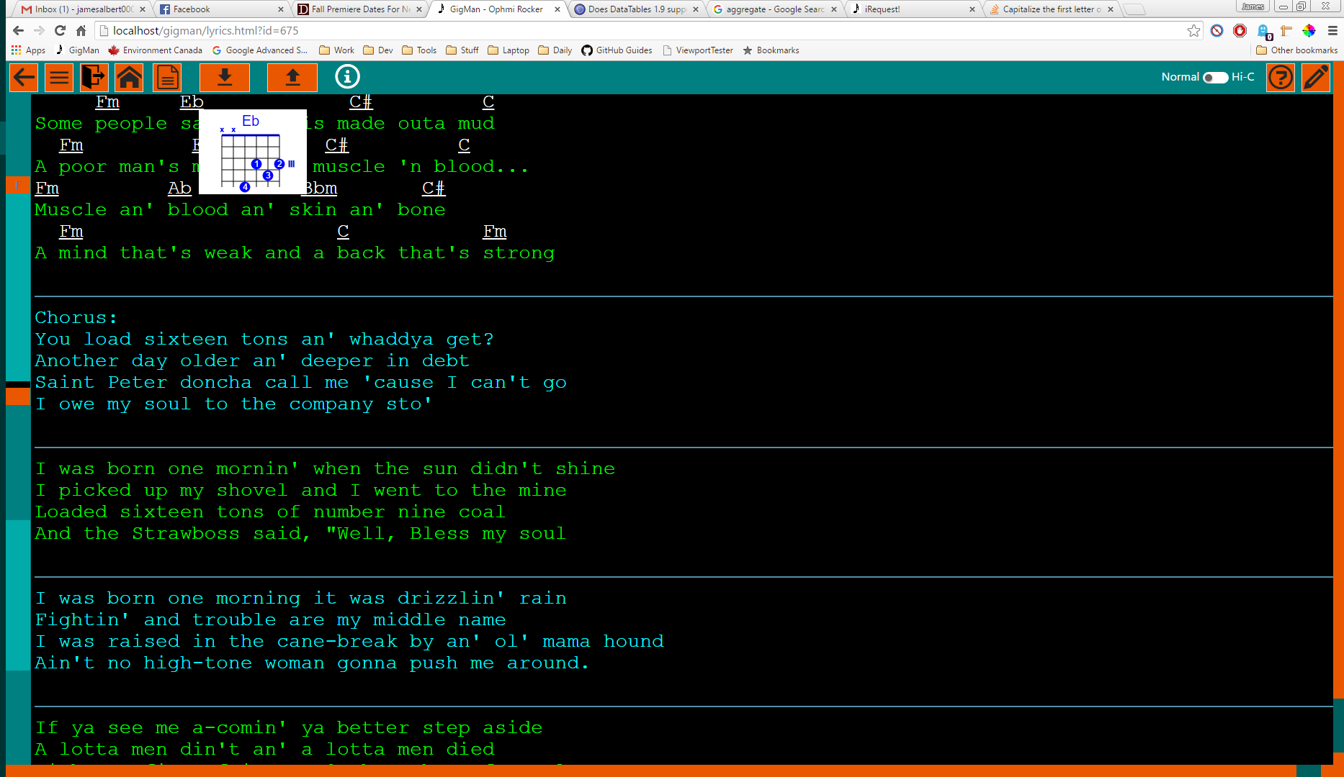

Figure Lyric View – Chords Transposed (from A minor to F minor)

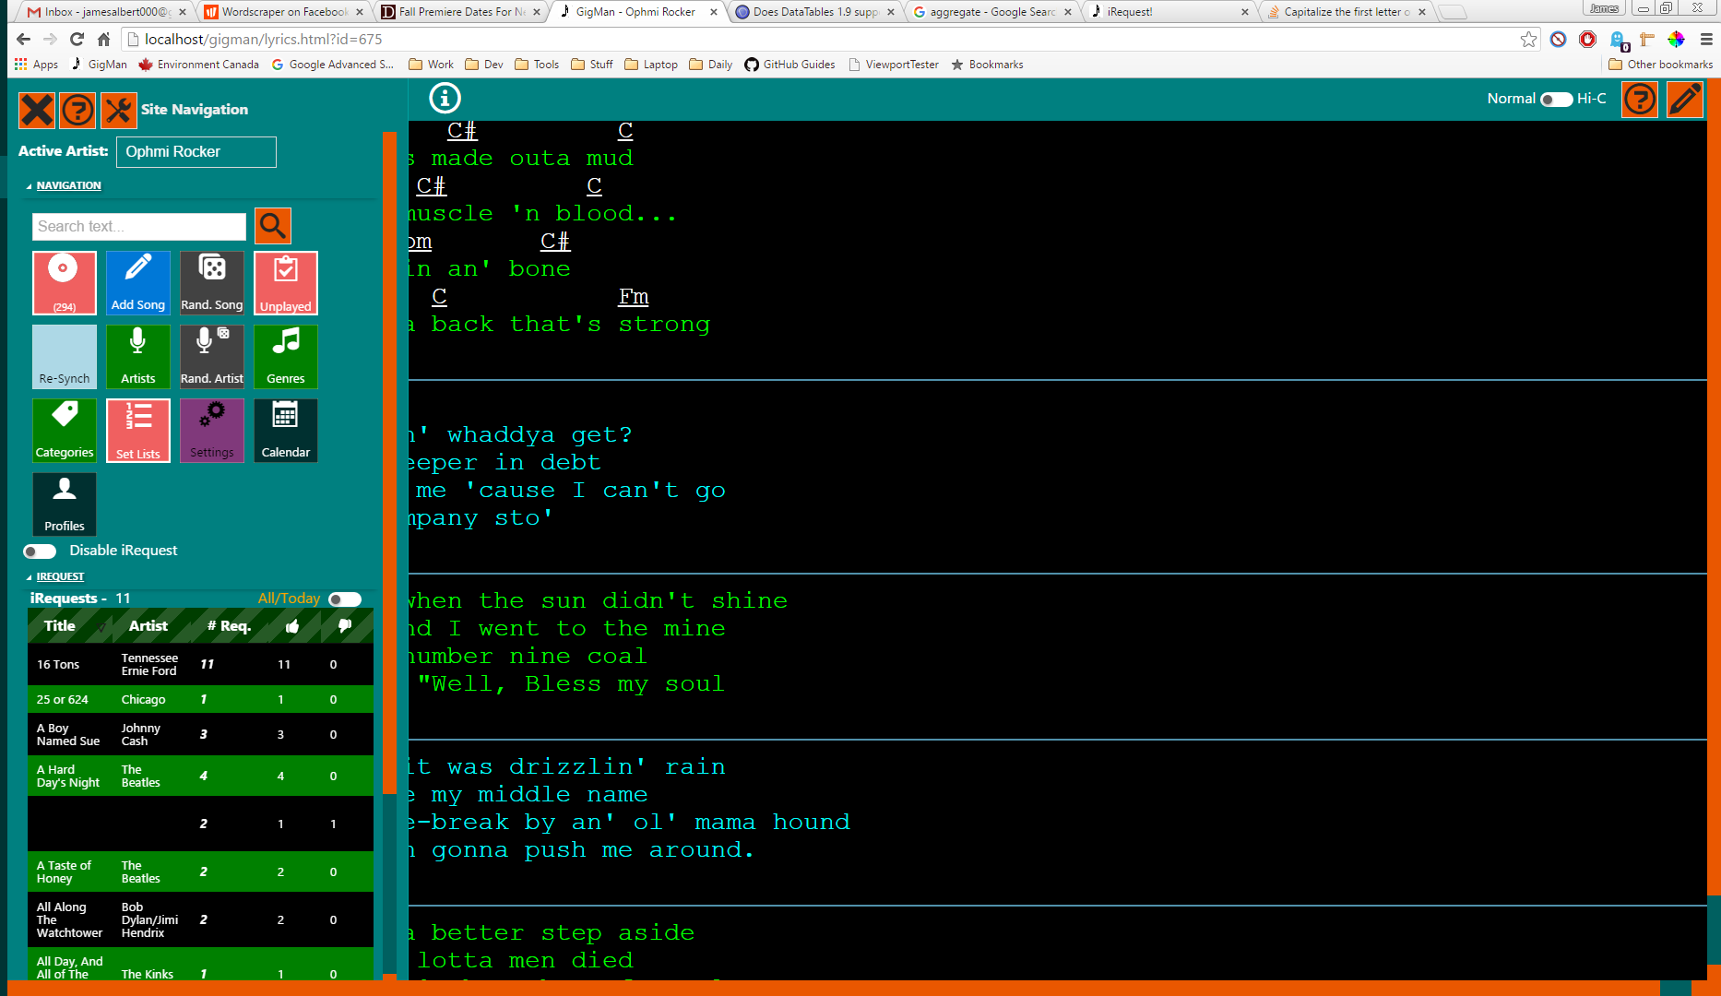

Figure Lyric View – Navigation Panel Open and iRequest Data Showing

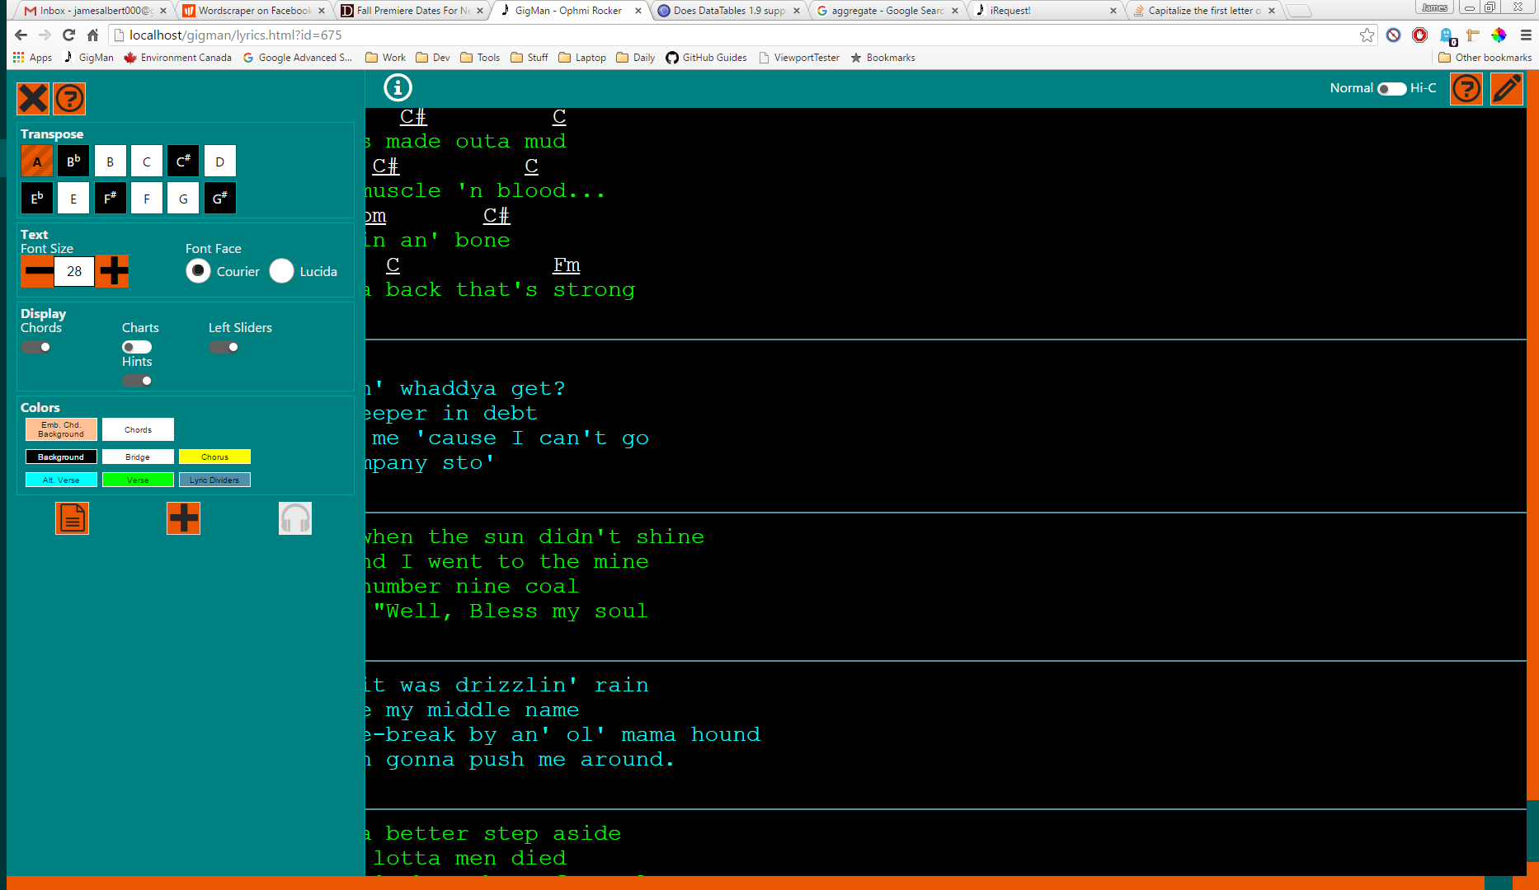

Figure 15 Lyric View – Lyric Toolbox Open

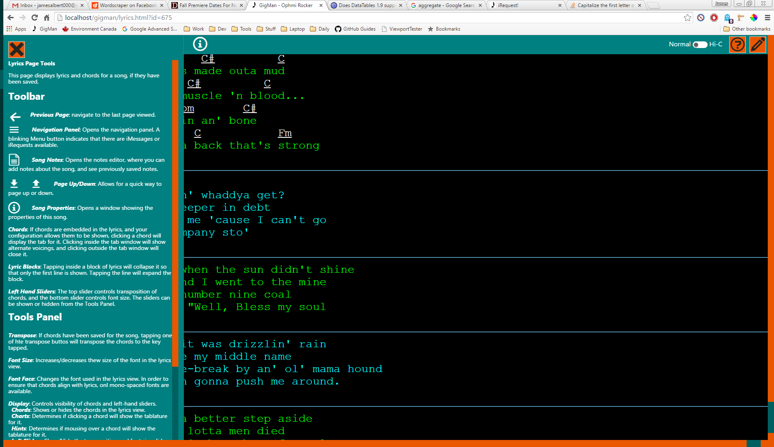

Figure 16 Lyric View – Contextual Help Panel Open

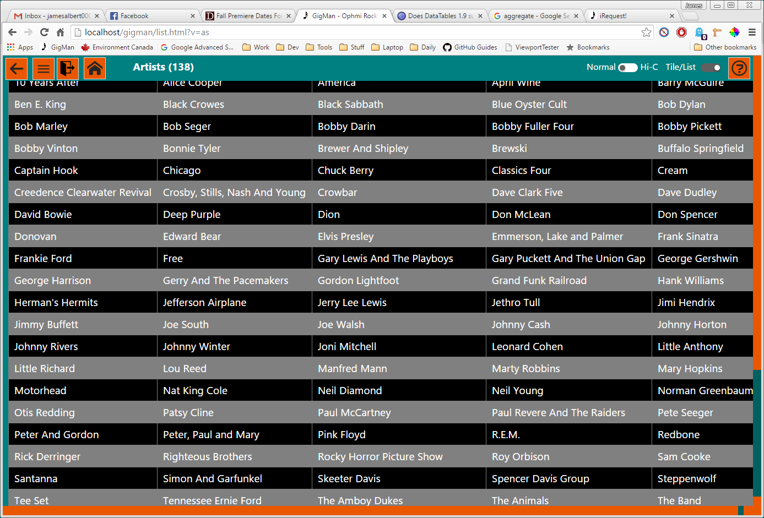

Figure GigMan – Master Artist List

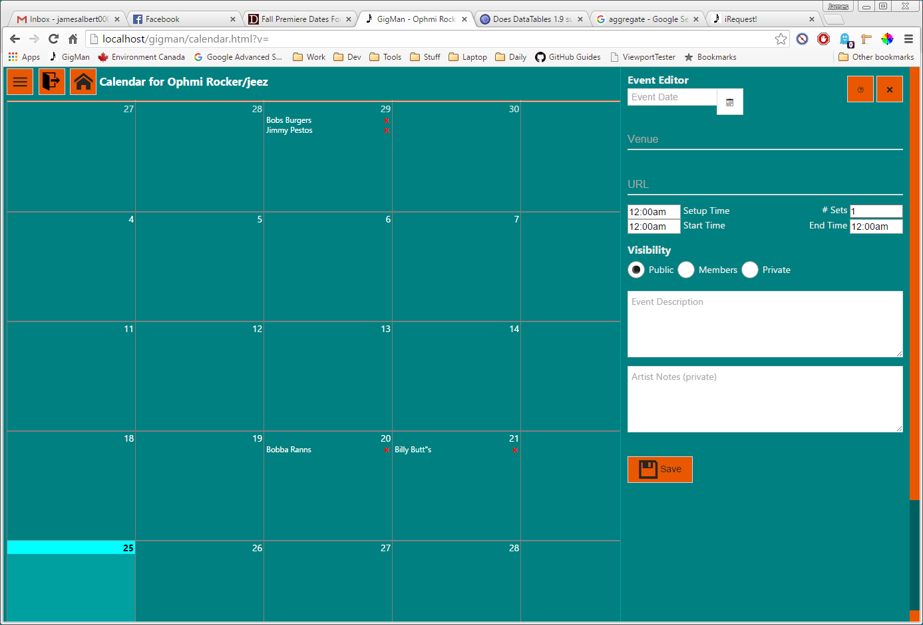

Figure GigMan – Calendar View, Event Editor Open

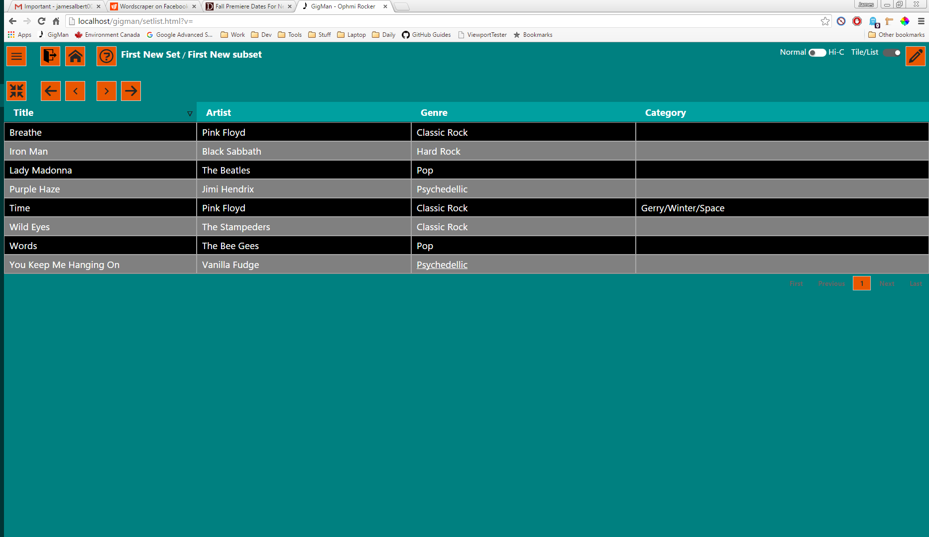

Figure Setlist Display Page

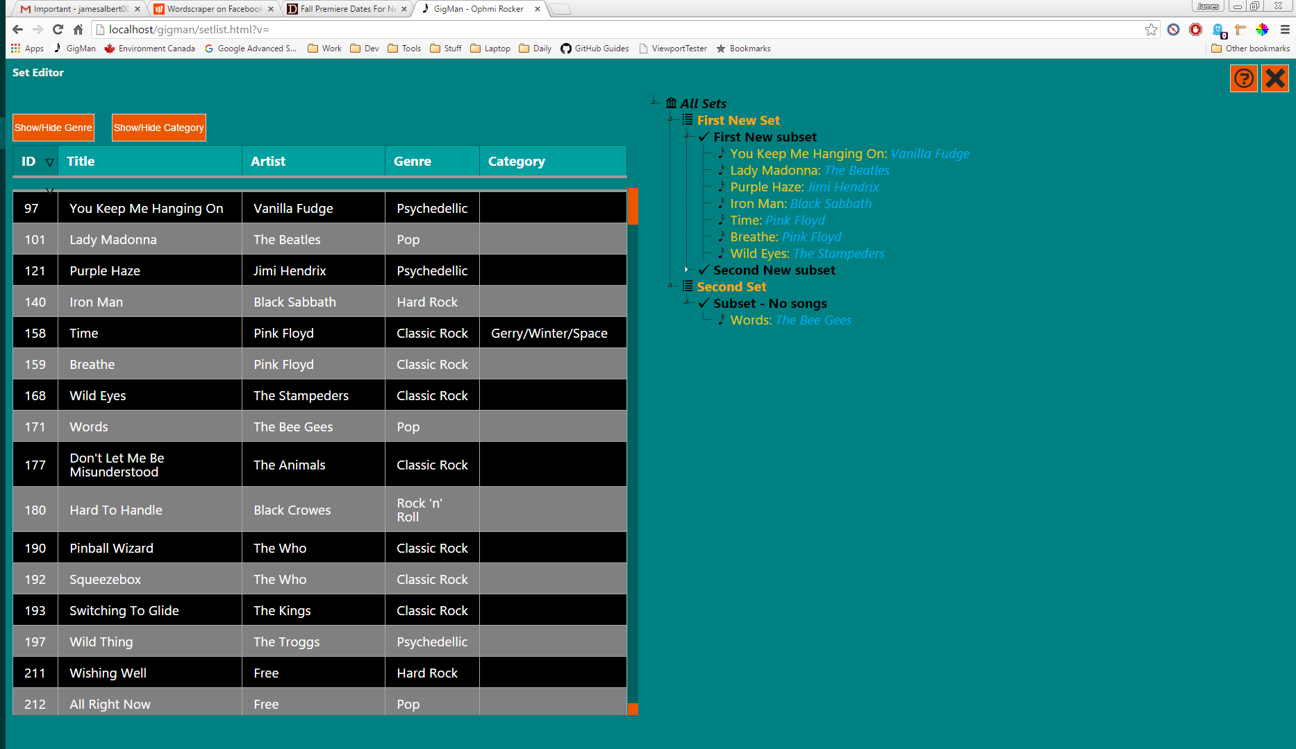

Figure Setlist Editor

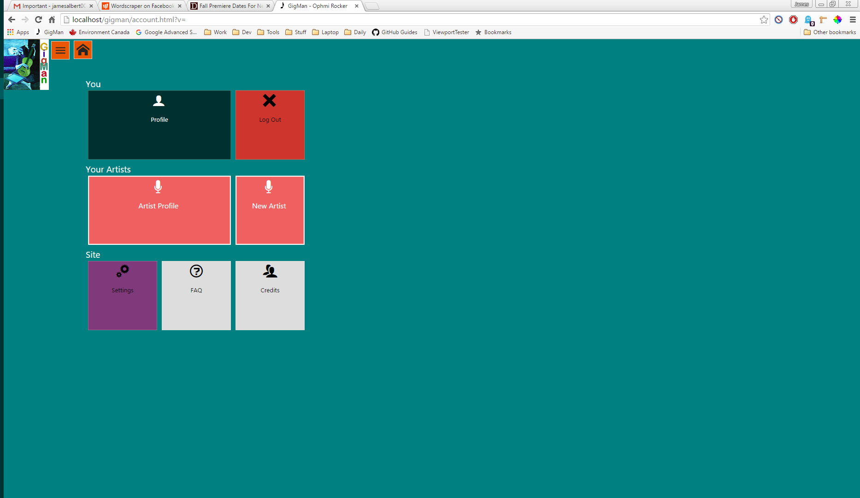

Figure Profiles Page

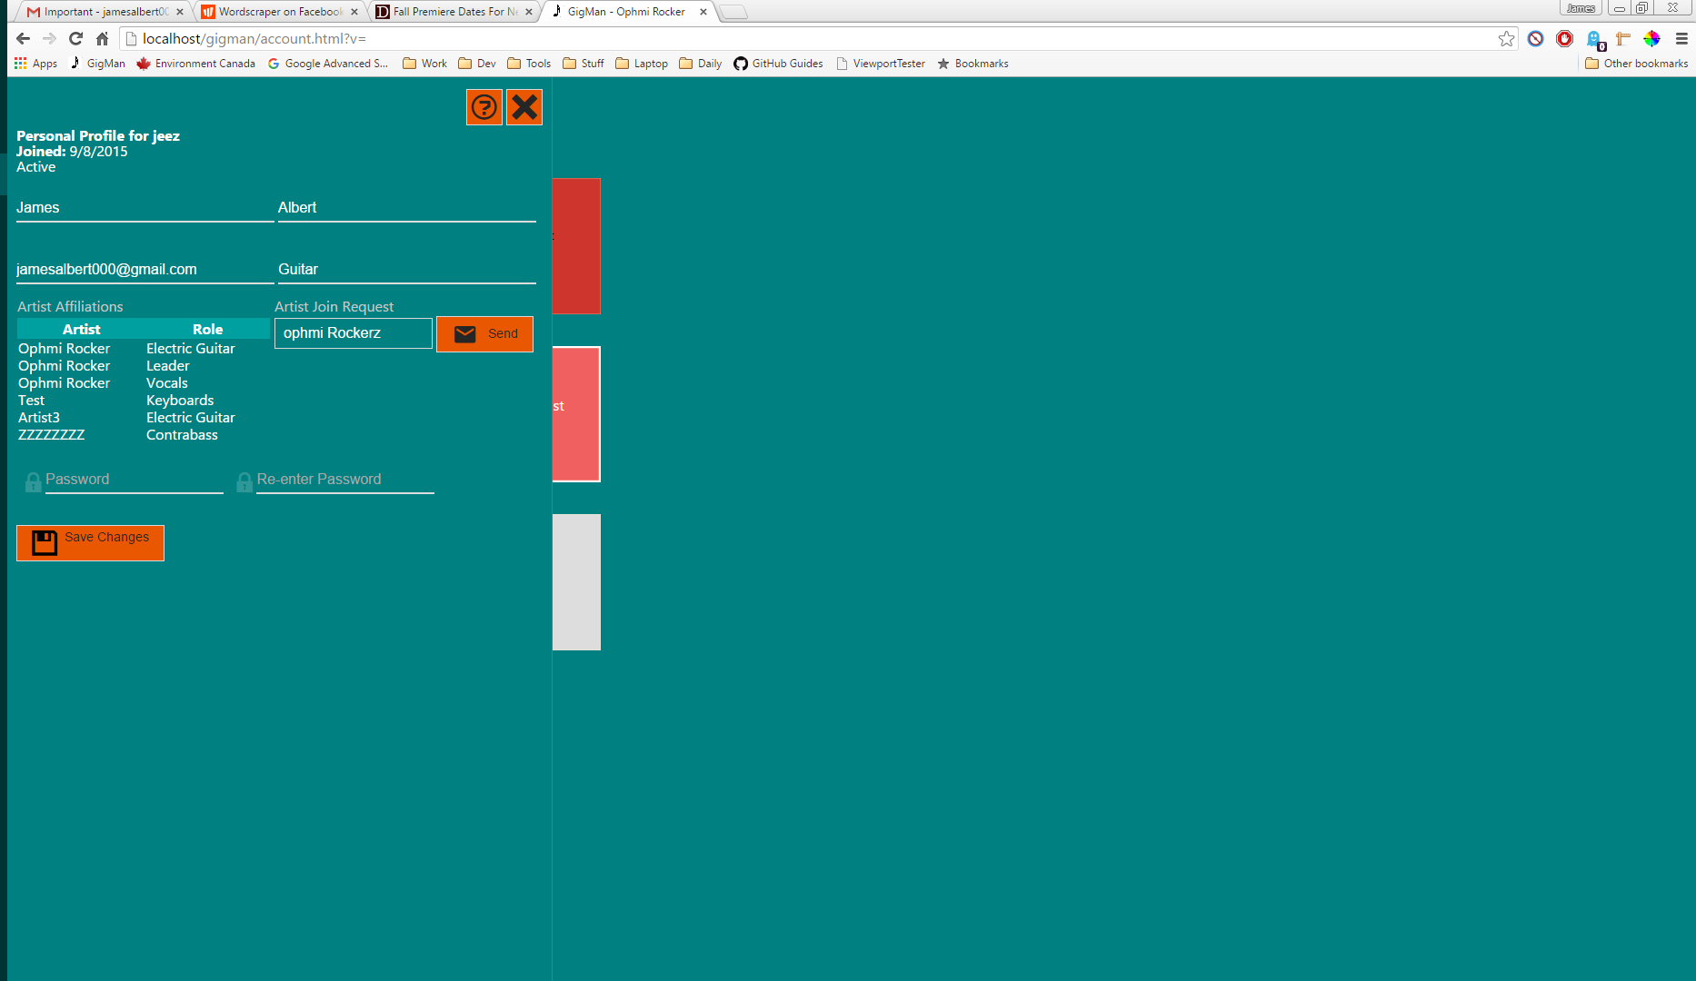

Figure Profile Page with User Profile Editor Open

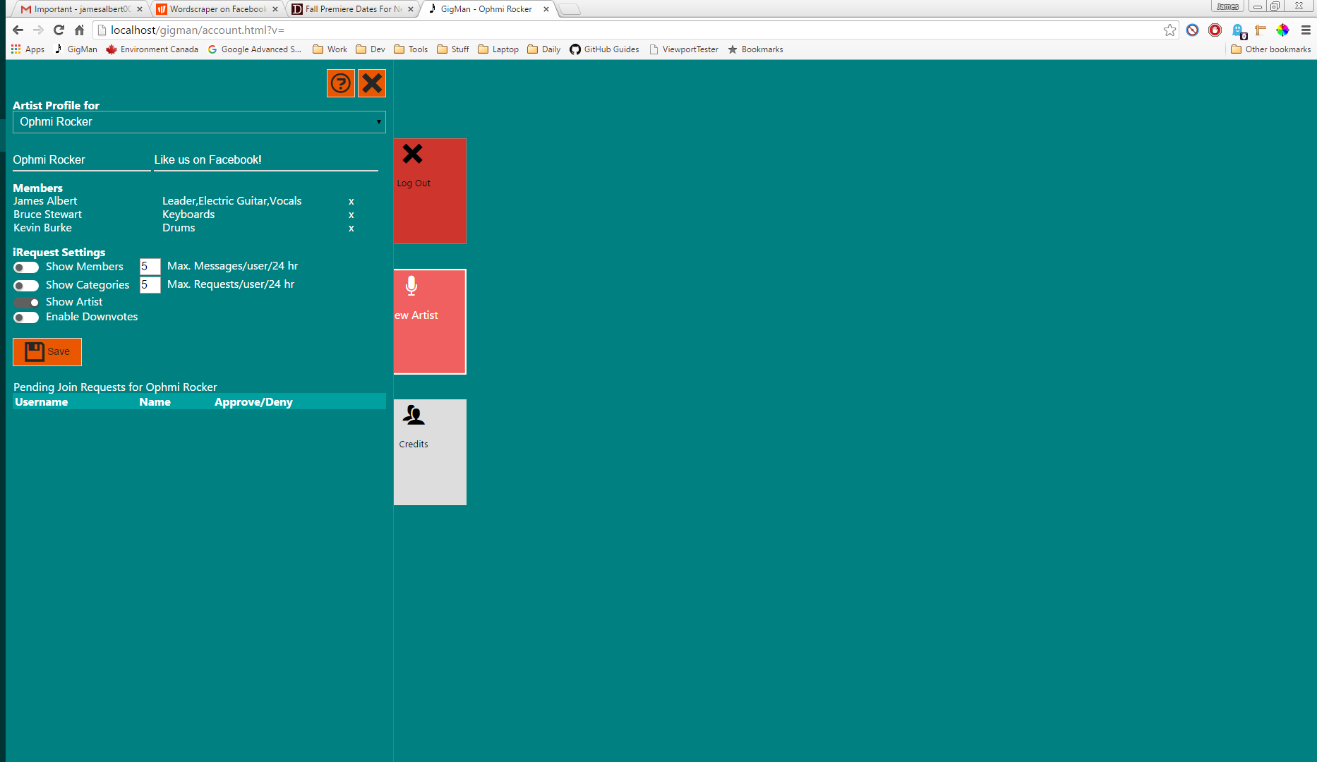

Figure Profile Page with Users Artist Affiliation Editor Open